**Date: ___________________ Name: ___________________**

**Popsicle Stick Bridge:**

**OVERVIEW:** To build the strongest bridge possible from pop sticks and PVA glue

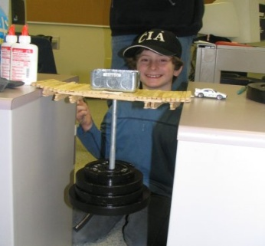**MATERIALS:**

* 50 popsicle sticks
* Glue Stick
* Weights

**RULES:**

1. Each bridge must be constructed from popsicle sticks and glue. No other materials or substitutions are allowed.
2. Contestants have 2 lessons in which to construct their bridge. Any modifications made to bridge after the allotted period will disqualify the bridge.
3. Each bridge must be freestanding; it must be at least 30cm long. It is recommended that all popsicle sticks are used.
4. Bridges must demonstrate consideration for appropriate building practices. Group members may be questioned on these.
5. Bridges, whether elevated or simply designed to cover the set distance, will be **peer** **assessed** on design and strength (see evaluation rubric).

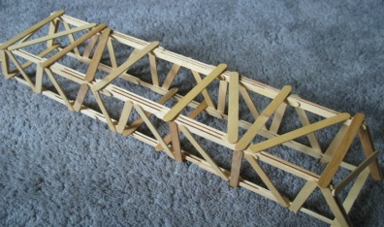

**JUDGING:**

1. Towers will be judged only once (peer assessment).
2. All contestants will start at the same time.
3. Weights will be added to the bridge at set intervals to determine the strength of each bridge.
4. The group with the strongest bridge (most weights) will be awarded a prize.

**AWARDS:**

1. Up to the teacher