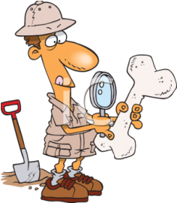
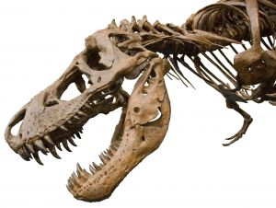
PALEoNTOLOGIST
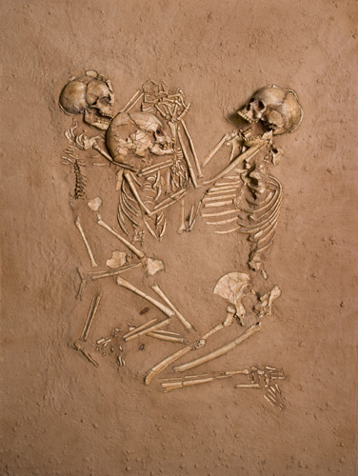
A palaeontologist studies the history of life on Earth. They look at

old fossils from plants, organisms, bacteria and even dinosaurs! By looking at fossils, paleontologist can find out the evolution of animals, fish and dinosaurs.
In this career, you would work outside in the field and also in a laboratory.
The area of science paleontology is found in biology and geology.
A surprising fact about this career is the finding of dinosaur bones and eggs by a guy named Roy Chapman Andrews. He discovered the eggs while working in the Mongolian desert.
Using paleontology, we can understand where came from and teaches about how animals are like today and what they were like in the past.
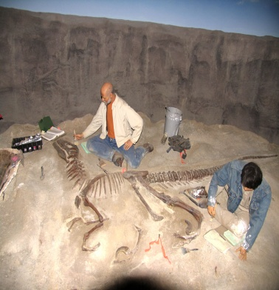
Bibliography: http://www.priweb.org/ed/lol/careers.htm
By: Hassan R
To: Mr. Mike

