|  |
| --- |
| Middle School |
| **STUDENT NAME:**   **CLASS: _______**  **TEACHER NAME:** |

|  |  |  |  |
| --- | --- | --- | --- |
| **UNIT: Megastructures**  **ISSUE TOPIC Megastructures and the Environment**  **ASSESSMENT TASK: Investigative Essay**  **ASSESSMENT DESCRIPTION:**   * Students are hired as investigative journalists to uncover the environmental secrets behind a chosen megastructure. * Students independently investigate one chosen megastructure. * Students research the positive and/or negative impacts that their chosen megastructure has had on the environment. * Students report their findings in a 400 word expose’ to be published in the *Gulf News*.   **CONDITIONS OF ASSESSMENT:**   * **Length: 400 words** * **Due Date: Wednesday 23rd March (Week 11)** * In class computer time will be given. * Scaffolding provided. | |  | **Science** |
|  |
| **YEAR 6/7**  **2010/2011**  **TERM 2**  **TASK: Megastructures & the Environment** |
| **SUMMARY OF RESULTS** | |
| **CRITERIA ASSESSED** | **STANDARD** |
| **KNOWLEDGE & UNDERSTANDING** |  |
| **INVESTIGATING** |  |
| **COMMUNICATING** |  |
| **REFLECTING** |  |
| **OVERALL RESULT** |  |



Your mission, should you choose to accept it...  
You have been asked by management at the *Gulf News*, to undertake a secretive and highly dangerous mission. Your task is to prepare an essay to be published in the newspaper which ***uncovers the impact that your chosen megastructure has had on the environment – good and/or bad.***

To complete your mission you will need to dig deep, investigating various elements associated with your megastructure. Use the Following outline as a guide.

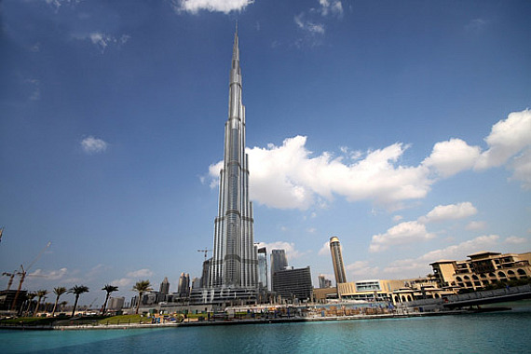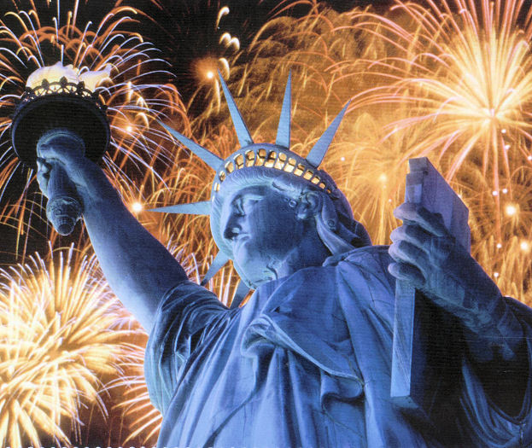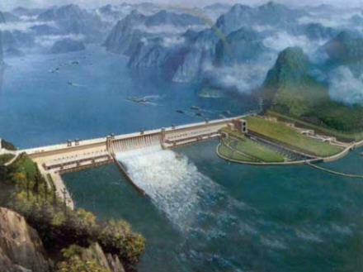

1. **Introduction (50 words)**

* A broad overview of the relationship between megastructures and the environment.
* Introduce your chosen megastructure.
* Briefly outline what you will be presenting in your essay – has your chosen megastructure had a positive and/or negative impact on the environment?
* Use a ‘connecting sentence’ to go from your introduction to your body.

1. **Body (250 words)**

* Describe the **first** positive/negative influence your megastructure has had on the environment – use research and references to support what you are saying.
* Describe the **second** positive/negative influence your megastructure has had on the environment – use research and references to support what you are saying.
* Use a ‘connecting sentence’ to go from your body to your conclusion.

1. **Conclusion (100 words)**

* Summarise the points you have raised in the body of your work.
* Draw a conclusion on the overall impact of your chosen megastructure on the environment – this should be the same as what you wrote in your introduction.
* Suggest measures to reduce or sustain the environmental impacts that currently exist.

SOME KEY QUESTIONS TO GUIDE YOUR INVESTIGATION:

* What impacts did the ***construction*** of your megastructure have on the environment? (eg. impact on surrounding wildlife, energy consumption, emissions)
* What impact does your megastructure have on the environment ***now***?
* Are there any ***future*** concerns for the environment because of your megastructure?
* Does your megastructure help the environment in any way?
* What are things that can be done to improve the impact that your megastructure has on the environment?

Good luck with your mission, and we look forward to hearing the truth. The world must know about these environmental goodies and baddies...

# Science – 6/7 Rotation 2, Term 2 – Megastructures & the Environment

### Student Name: __________________________________ Date: _____________

|  |  |  |  |  |  |  |  |  |  |  |  |
| --- | --- | --- | --- | --- | --- | --- | --- | --- | --- | --- | --- |
| **Report element**  *ESSENTIAL Learning*  **assessable element** | **Descriptors** | | | | | | | **K&U** | **Inv** | **comm** | **ref** |
| **E** | **D** | | **C** | **B** | | **A** |
| The student work typically demonstrates evidence of the following: | | | | | | |
| **Format** (e.g Title, Names, Bibliography, Intro-Body-Conclusion)  ***Contributes to evidence of the following Way/s of Working*** communicate scientific ideas, explanations, conclusions, decisions and data, using scientific argument and terminology, in appropriate formats  **Communication** | **Disjointed communication through:**  - Missing title and name.  - Missing bibliography.  - No distinction between intro, body and conclusion. | | **Sound communication through:**  - Title and or name included, not both.  - Adequately written bibliography with some information missing and/or written incorrectly.  - Evidence of an intro, body and conclusion can be identified. | | | **Clear and accurate communication through:**  - Appropriately written title and name included.  - Thoroughly documented bibliography, accurately written.  - Intro, body and conclusion are obvious. | |  |  |  |  |
| **Writing** (Spelling, grammar, punctuation, use of language)  ***Contributes to evidence of the following Way/s of Working* -** Communicate scientific ideas, data and evidence, using scientific terminology suited to the context and purpose.  **Communication** | **Disjointed communication through:**  - Poor spelling, grammar and punctuation with consistent errors.  - Poor use of language with consistently incoherent sentences. | | **Sound Communication through:**  - Sound spelling, grammar and punctuation with some errors.  - Sound use of language with mostly coherent sentences. | | | **Clear and accurate communication through:**  - Exceptional spelling, grammar and punctuation with few to no errors.  - Expert use of language to consistently produce well written and well constructed sentences. | |  |  |  |  |
| **Introduction** (Addresses the relationship between megastructures and the environment, identifies chosen megastructure, identifies the environmental impact of their megastructure)  **Contributes to evidence of the following Knowledge and Understanding -**  Ethical considerations are involved in decisions made about applications of science.  **Knowledge and Understanding**  **Investigating** | - A connection between megastructures and the environment is overlooked.  - Focal megastructure is either not mentioned or mentioned obscurely.  - Environmental impact of chosen megastructure is overlooked.  - Reliant upon teacher involvedment | | - Adequate attempt at offering a connection between megastructures and the environment.  - Identifies chosen megastructure and loosely mentions the environmental impact this megastructure has had.  - Some teacher assistance required. | | | - Offers a detailed and well researched connection between megastructures and their impact on the environment.  - Identifies chosen megastructure and explicitly outlines the impact this megastructure has had on the environment.  - Independent construction. | |  |  |  |  |
| **Body** (Identifies relevant effects that their megastructure has had on the environment, uses reputable research to support findings).  ***Contributes to evidence of the following***  ***Way/s of Working* -** collect and analyse  first- and second-hand data, information and  evidence.  ***Way/s of Working -*** communicate  scientific ideas, data and evidence, using  scientific terminology suited to the context  and purpose.  ***Way/s of Working -*** reflect on different  points of view and recognise and clarify  people’s values relating to the applications  and impacts of science.  ***Knowledge & Understanding*** - Ethical  considerations are involved in decisions  made about applications of science.  ***Knowledge & Understanding*** - Scientific  knowledge can help to make natural, social  and built environments sustainable, at a  scale ranging from local to global.  **Knowledge and Understanding**  **Investigating** | - Offers limited, unclear and irrelevant effects that chosen megastructure has on environment.  - Uses little or no research to support findings. Research used is unreliable.  - Acknowledgement of alternate opinions and/or views is not offered.  - Reliant upon teacher involvement. | | - Offers sufficient detail regarding 1-2 relevant effects that chosen megastructure has on environment.  - Uses some reputable research to support findings.  - Some references are made to alternate opinions and/or views.  - Some teacher assistance required. | | | - Offers significant detail to outline two or more highly relevant effects that chosen megastructure has on environment.  - Uses relevant and reputable research to support findings.  - Alternate opinions and/or views are identified thoroughly and accurately.  - Independent construction. | |  |  |  |  |
| **Conclusion** (Summarises points raised in body, draws conclusions regarding the overall impact of megastructure on the environment, offers solutions to reduce or sustain current environmental impact)  ***Contributes to evidence of the following Way/s of Working* -** reflect on different points of view and recognise and clarify people’s values relating to the applications and impacts of science.  ***Ways of Working*** - reflect on learning, apply new understandings and identify future applications.  ***Knowledge & Understanding*** – Ethical  considerations are involved in decisions  made about applications of science.  ***Knowledge & Understanding*** - Scientific  knowledge can help to make natural, social  and built environments sustainable, at a  scale ranging from local to global.  **Knowledge & Understanding**  **Reflecting** | Unclear or inaccurate hypothesis given.  Hypothesis given without links to evidence.  Reliant upon teacher involvement. | | Relevant hypothesis with links to evidence on which the hypothesis is based.  Some teacher assistance required | | | Clear hypothesis, with accurate and relevant details of the observations or evidence on which the hypothesis is based.  Independent construction | |  |  |  |  |
| **On Balance Judgement** | | | | | | | |  |  |  |  |

Comments:____________________________________________________________________________________________________________________________________________________________________________________________________________________________________________________________________________________