|  |
| --- |
| Yr. 6/7 SCIENCEMiddle School |
| **STUDENT NAME:**   **CLASS: _______**  **TEACHER NAME:** |

|  |  |  |  |
| --- | --- | --- | --- |
| **UNIT: Earth and Beyond**  **ISSUE TOPIC Discovery**  **ASSESSMENT TASK: Creating a Geologic Time Line**  **ASSESSMENT DESCRIPTION:**   * Students are hired as a geologist to fill in the missing pieces of how Earth’s History by creating a new “updated” version of the geologic time line. * Students will collaborate (in groups of 3), research, explore and identify major events that occurred in each Era, Period and Epoch of the geological time line. * Students will use a variety of sources such as the internet, class notes, text books and pictures to report their findings. * Students will then artistically re-create the geological time line of Earth’s history that will accurately illustrate the major events that took place during the various time periods; supported by text and pictures.   **CONDITIONS OF ASSESSMENT:**  **Length: 2 weeks: 6 full lessons of class time will be given**   * Resources suitable for this activity include Internet, classroom notes, text books * Time line will be submitted as a group of 3 | |  | **Science** |
|  |
| **YEAR 6/7**  **2010/2011**  **TERM 3**  **“Discovery”**  **ASSESSMENT TASK**  **Geologic Time Line**  **Due Date:**  **May 12th, 2011** |
| **SUMMARY OF RESULTS** | |
| **CRITERIA ASSESSED** | **STANDARD** |
| **KNOWLEDGE & UNDERSTANDING** |  |
| **INVESTIGATING** |  |
| **COMMUNICATING** |  |
| **OVERALL RESULT** |  |

**DIGGING UP EARTH’S GEOLOGIC TIME LINE**

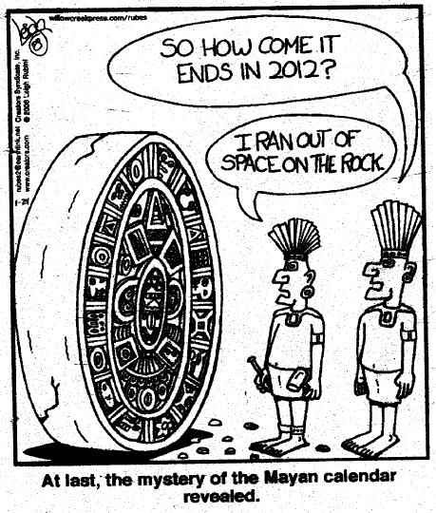You have been asked by the reputable travel magazine, *National Geographic* to undertake a daunting task. *National Geographic* is looking to hire a group of young students to put a new “spin” on the already existing geologic time line. They believe the geologic time lines that have been previously used and seen in their magazines do not appeal to a younger demographic. *National Geographic* would like to publish your “new” geologic time line in their **May Issue**. This time line should have a “fresh” and “attractive appearance” that can be easy understood. It should incorporate all the “**major events”** of Earth’s history with accompanying pictures!

To complete your task, you will need to dig deep, explore and identify the bare bones of this geologic time line.

***Task:***

Your task as a geologist is to re-create Earth’s Geological Time Line that is easy to interpret and understand without taking away the main content. The directions on the next page must be carefully followed in order to complete this task!



***Making a Geologic Time Line***

**Procedure:**

1. Retrieve large pieces of paper from your teacher.
2. Arrange the paper so that it is in a landscape direction. Put the paper end to end until there is 5 meters of copying paper.
3. Using clear transparent tape, tape the paper together so that there is 5 meters of total paper. Make sure your work is not seen on the taped side.
4. Using a meter stick, draw a line through the middle of the paper.

Distance= 5 m

1. In the top left corner, make a scale. Label the scale: 1 cm= 10 million years
2. Starting on the left side of the paper, measure 5 cm, to the right on the line and make a vertical mark. Label this mark with the word **PRESENT DAY (2011)**
3. From this mark, measure 1 meter to the right on this line and make a vertical mark. Label this mark 1 billion years. Measure and mark each meter after that up to 4 meters or 4 billion years from today.
4. Now measure 60 cm to make the total length of the time line 4.6 meters. Mark and label the distance 4.6 billion years **(BEGINNING OF TIME)**
5. By using 4 different colours, label the year and name of each **ERA** on your geologic time scale. Using the scale 1cm =10 million years, measure the distance to each era from TODAY by using the following information.

**ERAS**

1. Cenozoic Era =65 million years ago = ___________cm from today
2. Mesozoic Era =245 million years ago=____________cm from today
3. Paleozoic Era =545 million years ago=____________cm from today
4. Precambrian Era =4.6 **billion** years ago=____________cm from today
5. Write the names of each **PERIOD** in the geologic time scale (preferably with a different colour) by using the basic geological time scale as a guide (date page 7).
6. Find and cut out 1-3 pictures/images of the **major events** that took place during each **PERIOD** and paste them onto the scale.
7. For those students who are aiming to receive an A in this assessment:

Incorporate the subdivision of **PERIODS, EPOCHS** into your time line with accompanying pictures and images. Be sure to colour the **EPOCH** division differently than the **PERIOD** division.