DISCOVERY REVISION

- List the planets in order from furthest to closest to the sun.
______________________________________________________________________________________________________________________________________________________________________________________________________________________________________________________

- The four closest planets to the sun are known as what?
__________________________________________________________________________________

- Between Mars and Jupiter is the what?
__________________________________________________________________________________

- List the four Jovian planets and describe what they have in common.
______________________________________________________________________________________________________________________________________________________________________________________________________________________________________________________

- Colour in the following moons according to their shapes at different phases. Write the days into the month for each moon.

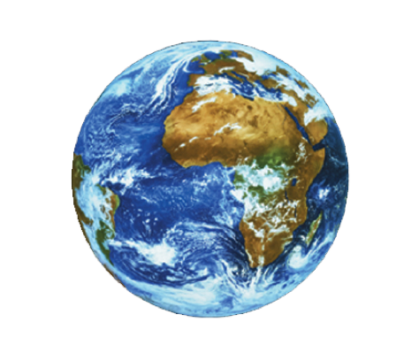
Sun

- Explain the difference between a neap and a spring tide. Draw four diagrams to show your understanding (2 for each).
________________________________________________________________________________________________________________________________________________________________________________________________________________________________________________________________________________________________________________________________________

- What is a new moon?
______________________________________________________________________________________________________________________________________________________________________________________________________________________________________________________

- Draw a diagram using the EARTH, the MOON and the SUN to describe when our Earth sees the biggest tides. Why are these tides the largest?

________________________________________________________________________________________________________________________________________________________________________________________________________________________________________________________________________________________________________________________________________

